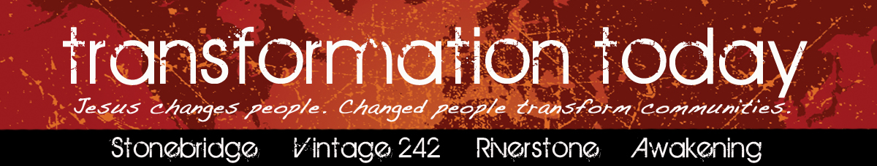

October 2011

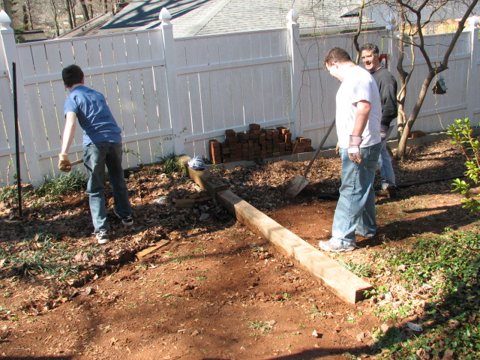

***Members of Stonebridge offer monthly home repairs to someone in their community. Jerry Pfeuffer and his team assemble a ramp at a local home.***

***Volunteers from network churches prepare the Cobb Civic Center for Born Again Blessings, a network-wide children’s consignment sale. Over $15,000 was given to the Barnabas Fund, which provides financial help to members of our community.***

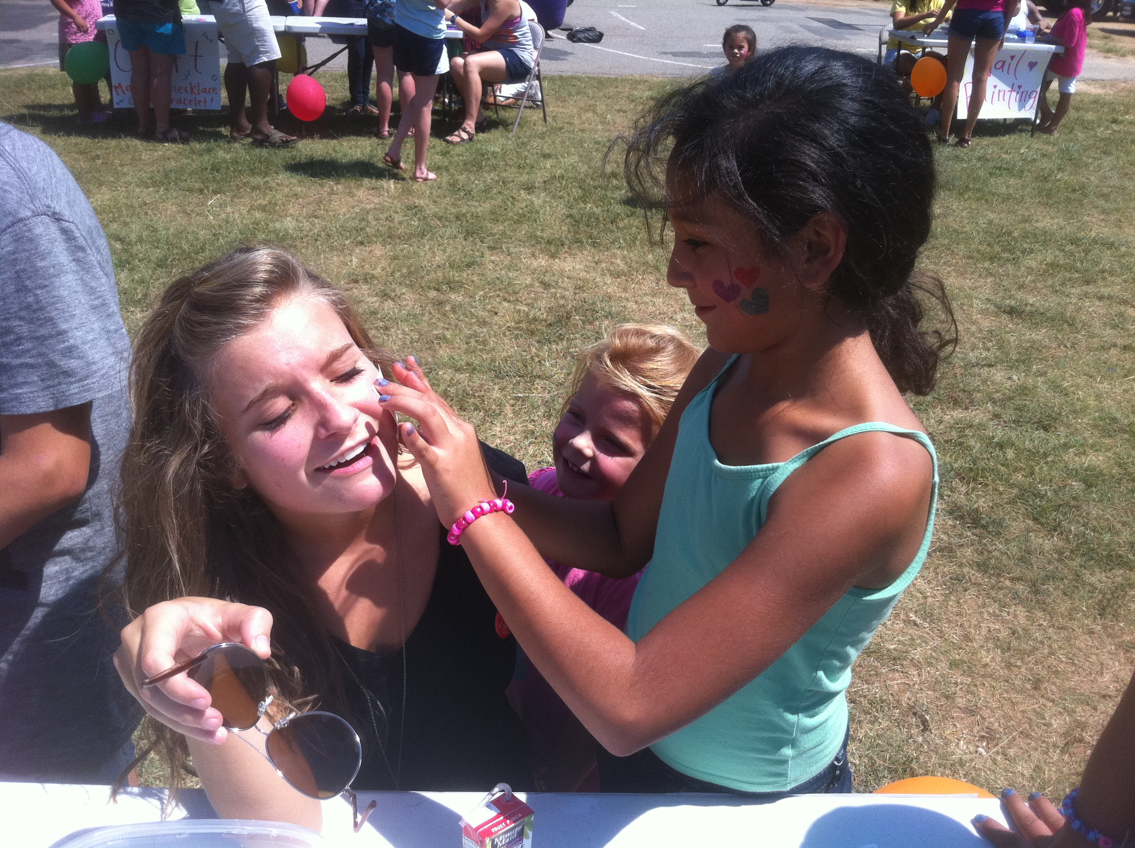

***RiverStone youth reach out to Castle Lake Mobile Homes.***

## Our Community *TRANSFORMED*

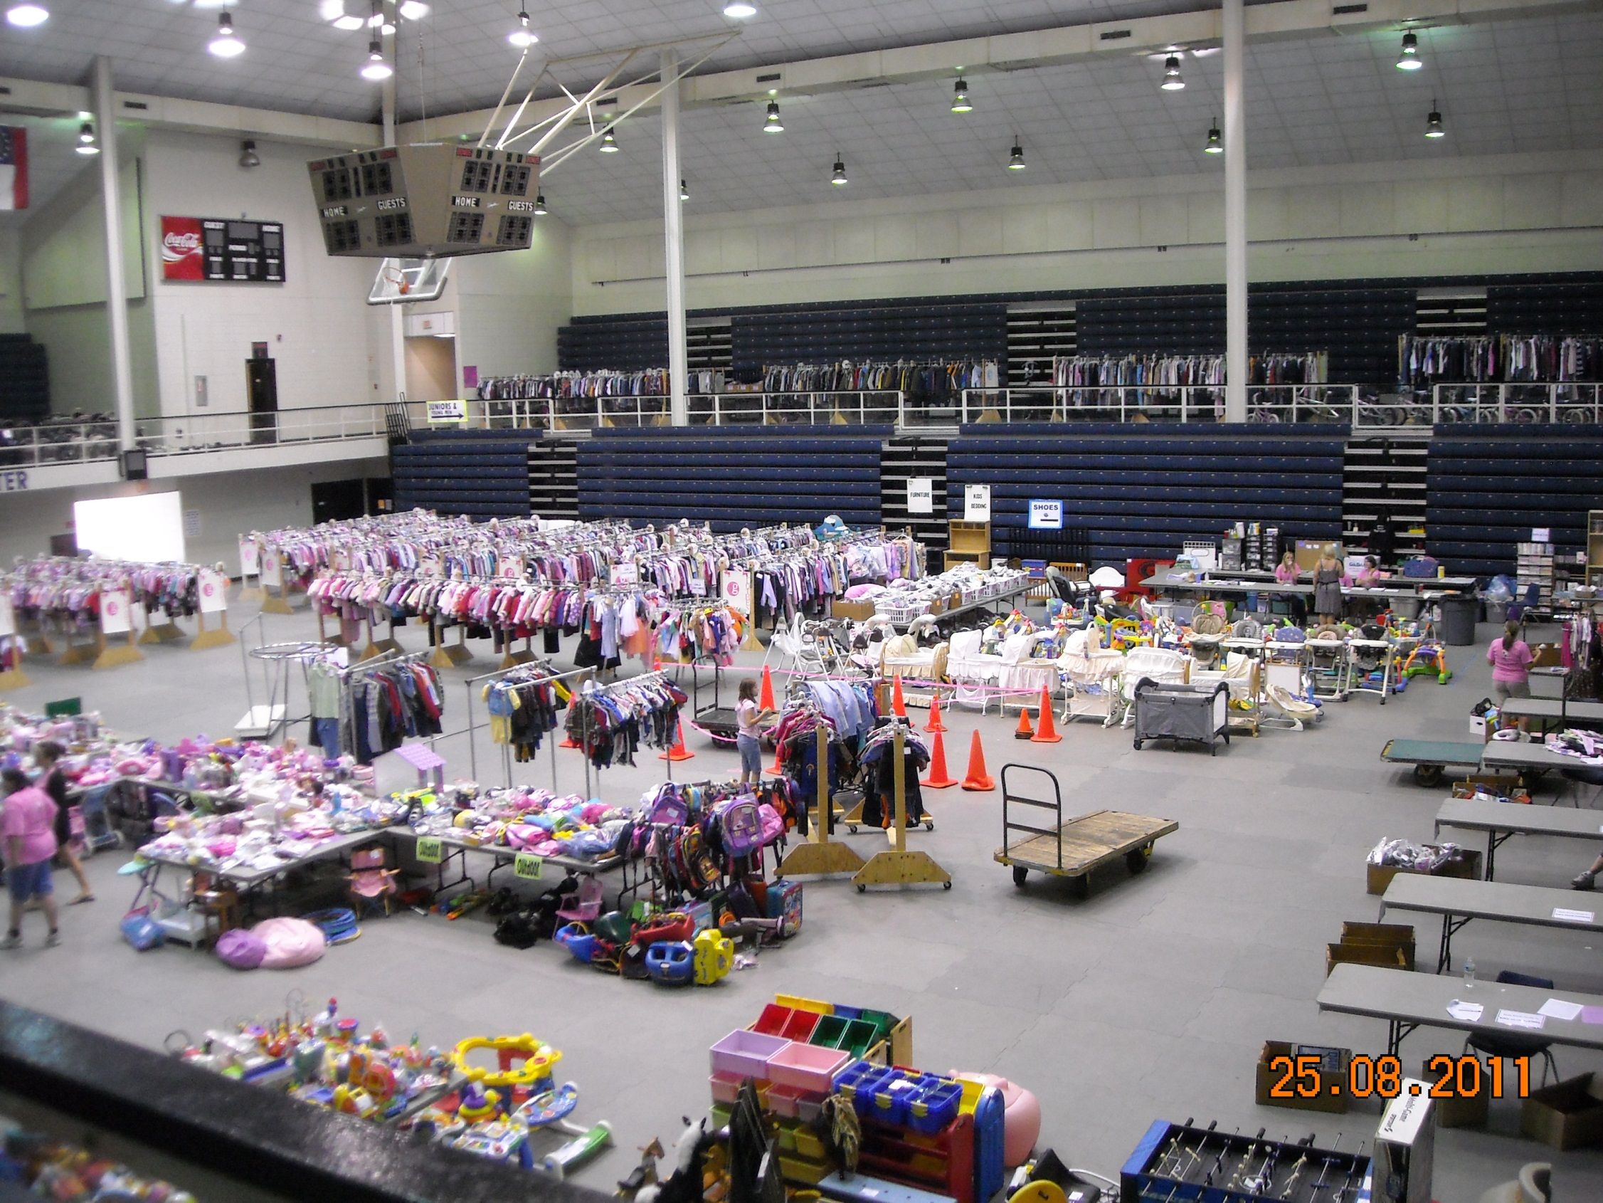

Because of expressed interest in one of the four churches listed on the header of this newsletter, you’re receiving ***TRANSFORMATION TODAY***. These churches make up the Transformation Network. As a ministry we exist to see the northwest metro area transformed by God. Our strategy is to plant and nurture churches with similar values and different expressions.

***TRANSFORMATION TODAY*** is designed to rally your faith for community transformation. It will highlight transformation in nations and people groups across the earth. One of our seven values that releases supernatural change will be explored. Personal stories of transformation, network news and events are included. Finally, you will see the way community transformation is happening through Stonebridge, Awakening, Vintage 242 and RiverStone. Read how God is changing Cobb and surrounding counties and believe for more.

What in the World is Really Happening?



†Every eight seconds in the world another person indicates a decision to follow Christ after watching the "JESUS" film. **T**hat's 10,800 people per day, 324,000 per month and more than 3.8 million per year! That’s like the population of the entire city of Pittsburgh, PA coming to Christ every 28 ¼ days. Since 1979 more than 200 million men, women and children worldwide have indicated decisions to follow Jesus after viewing the film. *(Jesus Film)*

†The Iranian government is showing concern about the large quantities of Bibles entering the country. Many government officials believe the purpose of Christians

## Endless Expressions: Transformation Described

## Values Matter: the Lordship of Jesus Christ

***Jesus Knows Your Cell Number***

purpose of Christianity is to confront Islam. Iranian officials have always been against Muslim conversions to Christianity. Three decades of propaganda against Christianity has not deterred many Iranians from seeking the gospel. *(Voice of Martyrs)*

† “By tomorrow, there will be 175,000 more Christians than there are today. That means, no matter how rotten a day you have today, no matter how many things go haywire, when the sun comes up tomorrow you will have 175,000 new brother and sisters in Christ in 238 nations around the world!” *(James Rutz)*

†Many Christians have fled the city of Maiduguri in northern Nigeria, fearing large-scale attacks by Islamic extremists. Church attendance has dropped drastically and police have boarded up many churches and placed them under police or military guard. The Christian Association of Nigeria has advised churches that remain open to suspend or reschedule services to outwit potential attackers. *(Compass Direct News)*

Recently I heard the story of a Muslim husband whose wife was very sick.  In a dream a Man in a white robe gives the husband a phone number.  The Muslim awakens and calls the number.  A Christian pastor answers his cell phone.  After hearing the Muslim’s story, the pastor shares that he knows some people that could pray for the wife’s healing and introduce them to the Man in his dream. The husband and healed wife are now followers of Jesus. We as a network value the **Lordship of Jesus Christ**.  That means we commit to worship Him, obey Him and make Him known.  As Lord of heaven and earth, Jesus knows how to bring about his purposes in the earth even if it is revealing a cell number.  What happens when we as network churches submit fully to Jesus’ Lordship? Community transformation starts popping up everywhere. The Lordship of Jesus is not only good theology.  It is good practice.  At the Name of Jesus every knee should bow.

-***Mark Nysewander, Executive Director, Transformation Network***

Mark your calendars for the **CONNECT Conference** on **March 2-4, 2012**. Join your network family for a weekend of fellowship, prayer and worship.

**Awakening Church** had an ordination service for their pastors, Jeff Whitmire and Jayson Moss, on August 26.

**Transformation Network** is considering a network-wide mission trip to Egypt in April 2012. Interested? Email Pam Otto at **pam.otto@mindspring.com**.

## Network News: What’s Happening

The Transformation Network Board is made up of a group of pastors and leaders who gather together monthly to pursue God’s heart for our churches and the new plants that lie ahead of us.  Over the past 10+ years I have been a part of this amazing church body.  I’ve learned so much about God’s heart for me and for us, and I continue to grow more passionate each week. When asked to serve on the Network board, I was honored to share my heart for our body. I said 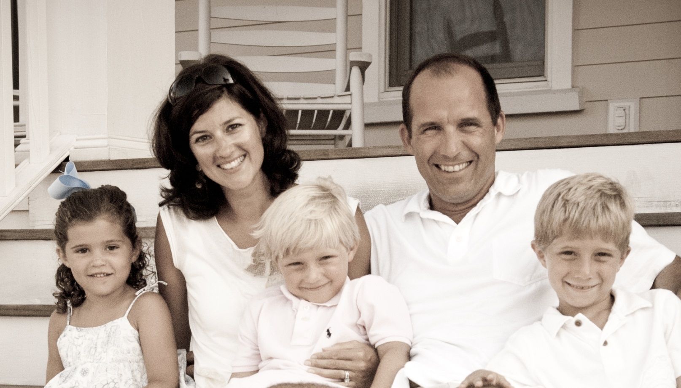

yes to the call, mainly due to my desire to see our churches unite with one another. My soul and spirit feel right when we are all together during times like Kingdom Expansion, Born Again Blessings, Face Down, Healing Prayer, Sozo, etc. It’s a privilege to serve our body in pursuing God’s heart for

God’s heart for us. It’s an honor to see how our pastors move with God. And it’s awesome to see and feel and taste and know the goodness when we are all united together. If you can’t see it, look for it. It’s a fire…gather around it!

***-Ben Barfield***

## No Limits: Personal Stories of Transformation